**Tugas VRVEX Line Detector (T-17)**

* **Line Detector (Counting One Block– A)**

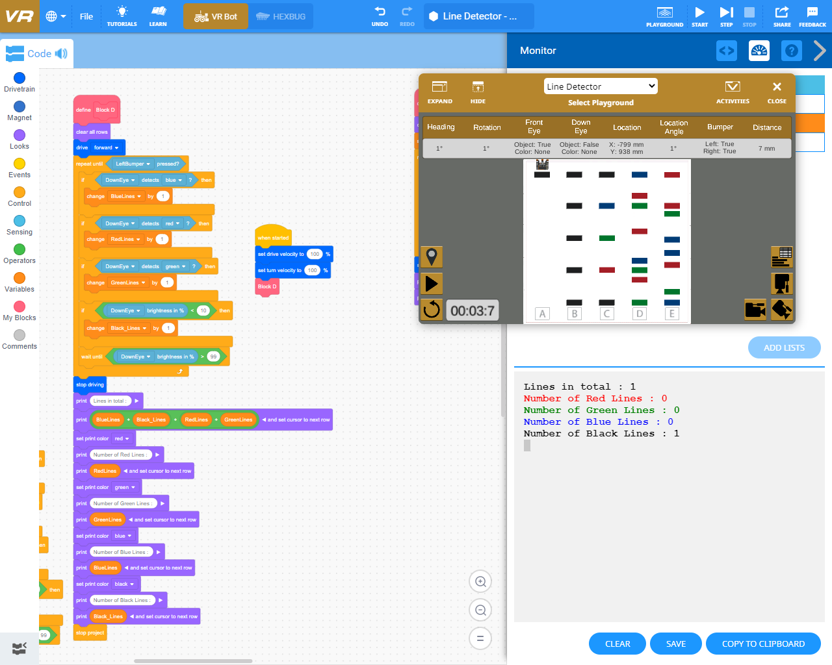

* **Line Detector (Counting One Block – B)**

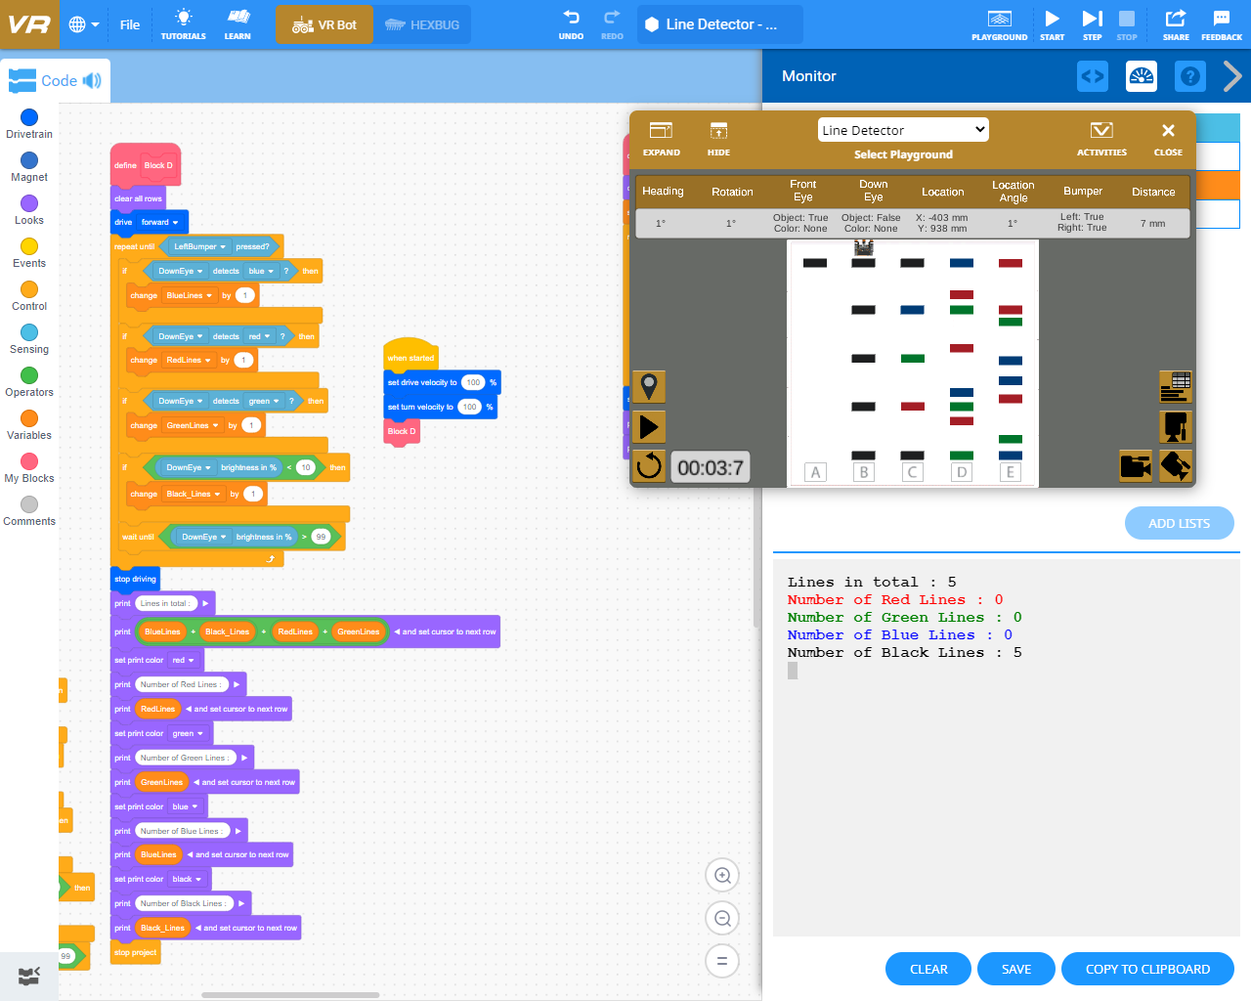

* 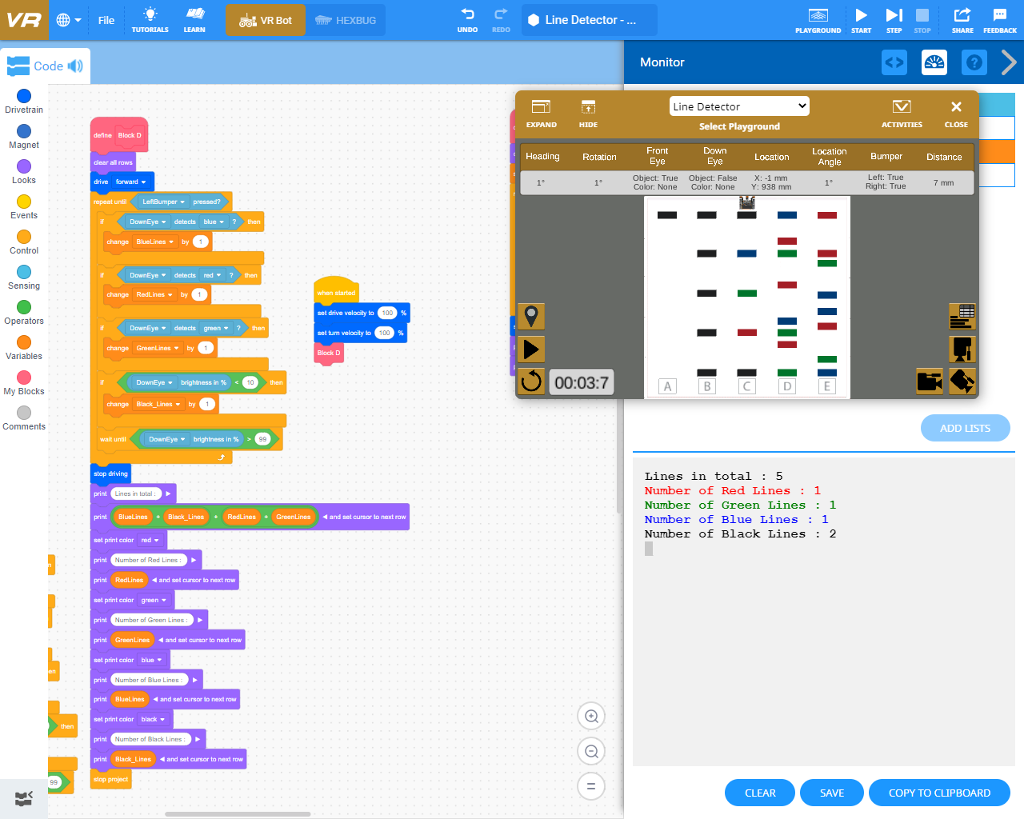**Line Detector (Counting One Block – C)**
* 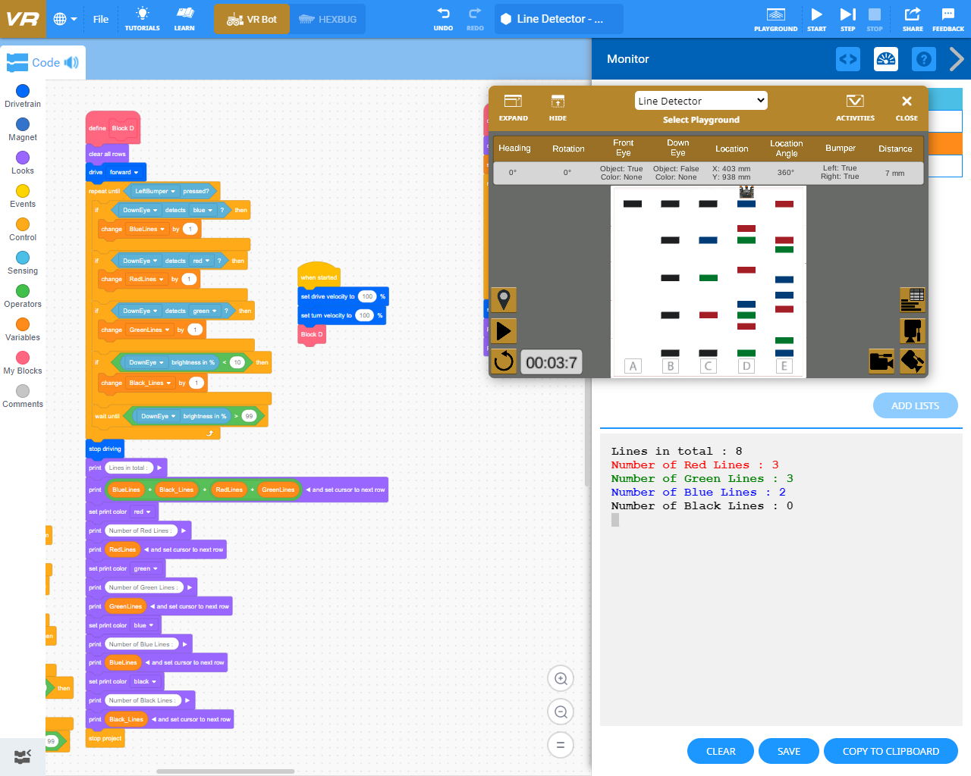**Line Detector (Counting One Block – D)**
* 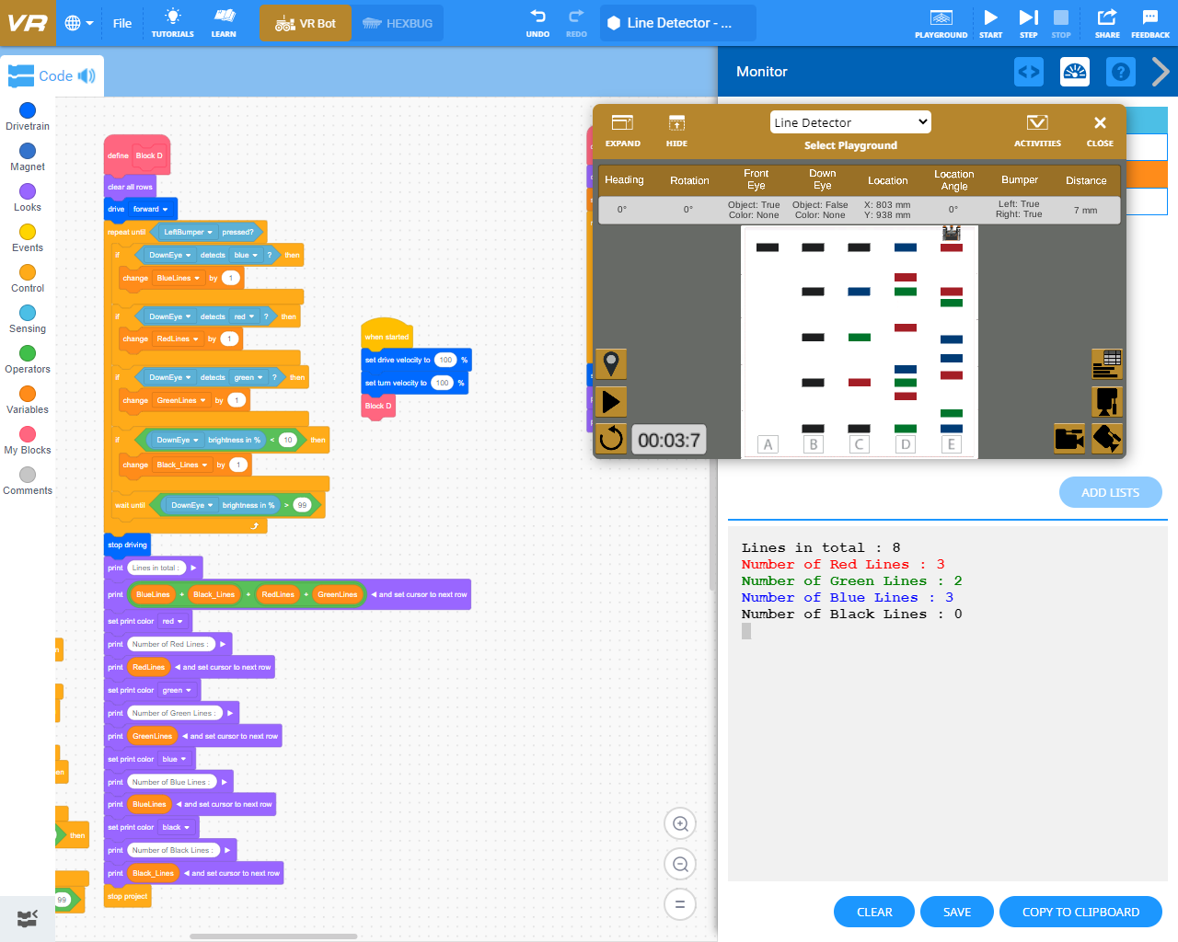**Line Detector (Counting One Block – E)**
* 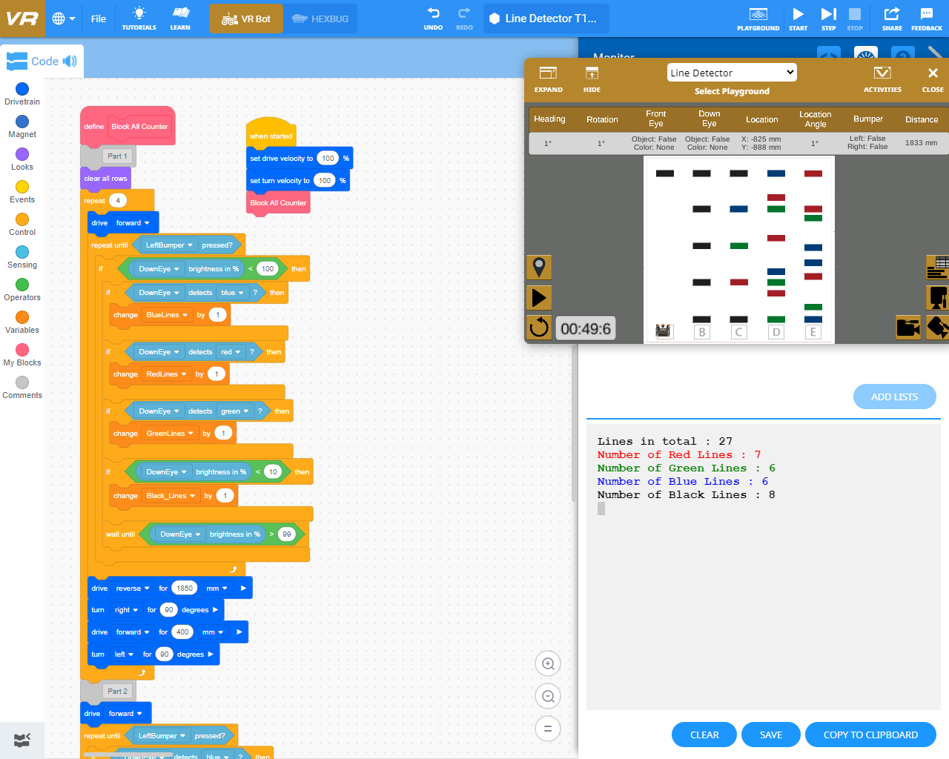**Line Detector (Counting All Block)**
* 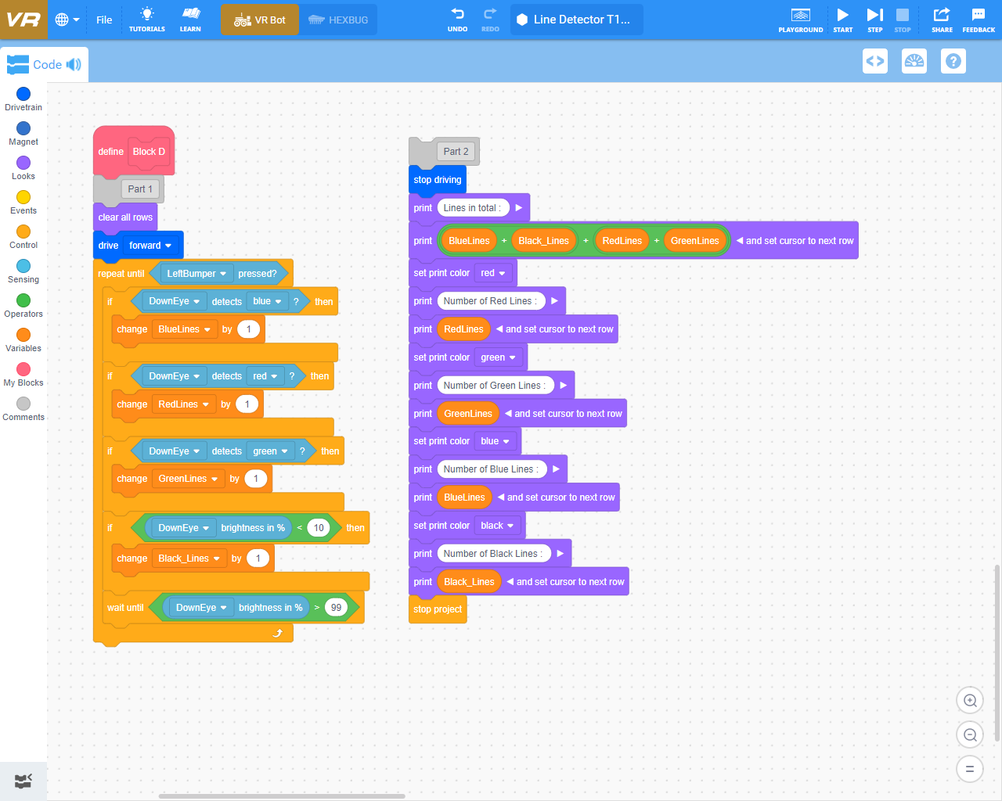**Counting One Block Code**
* **Counting All Block Code**

